anxiousaboutaging.com
Bring Home from Hospital Checklist
(Look at this BEFORE leaving to pick up your loved one on discharge)

Doctor | Tasks
 | Ask for an explanation of how your loved one is doing
 | Review medication list in detail (starting, stopping, or different doses of medication)
 | Ask if side effects of new medications
 | Review follow up plan, reasons to come back to hospital
Nurse | Tasks
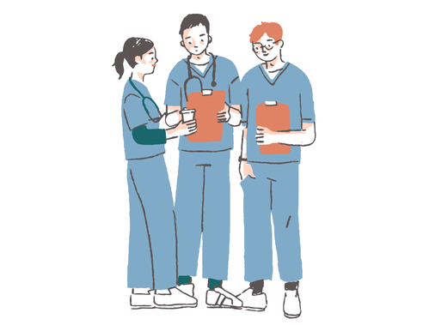 | Review discharge instruction list
 | Discuss any changes to diet, restrictions of salt intake/water intake, change to diet texture (i.e. pureed or soft diet needed)
 | Review changes to activity (need walker? cane? wheelchair?)
 | Discuss when best time to pick up loved one is
Pharmacy | Tasks
 | Pick up new prescriptions
 | Discuss with pharmacist if any side effects or medication interactions
 | Discard any old/unused medications
 | Get medication box dispenser if you don’t have one
Loved One | Tasks
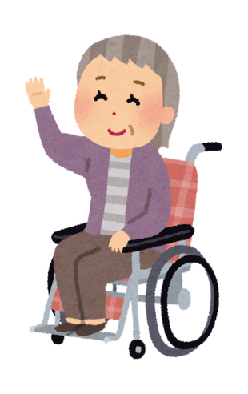 | Check with loved one if clothes or personal items should be brought
 | Confirm receipt from hospital of glasses, dentures, hearing aids, phone, wallet/purse, jewelry.
 | Confirm loved one can transfer into vehicle
 | Make sure you have access to the home

